Installation of GAMESS-INTERFACE

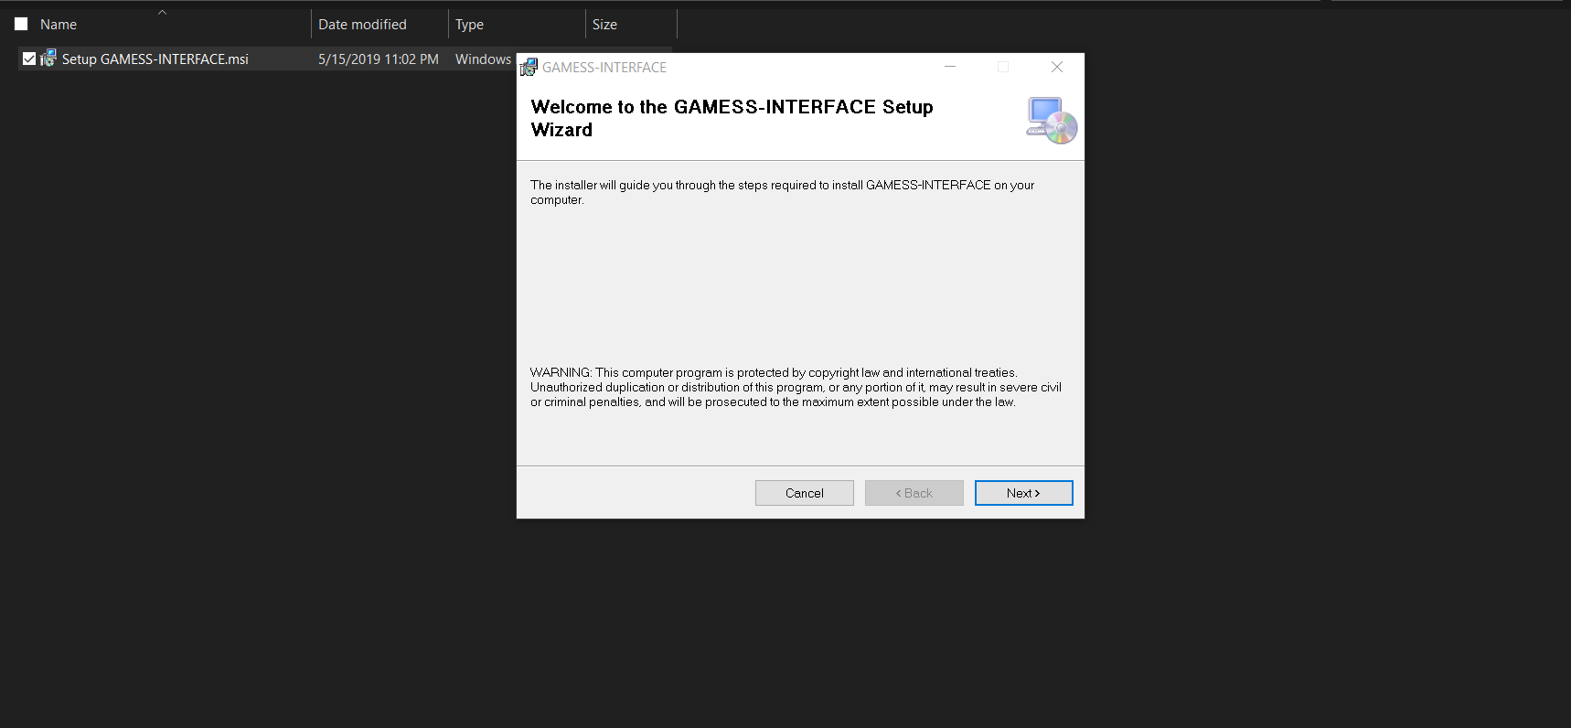

Double-click on the installer file to begin the installation.

Click next.

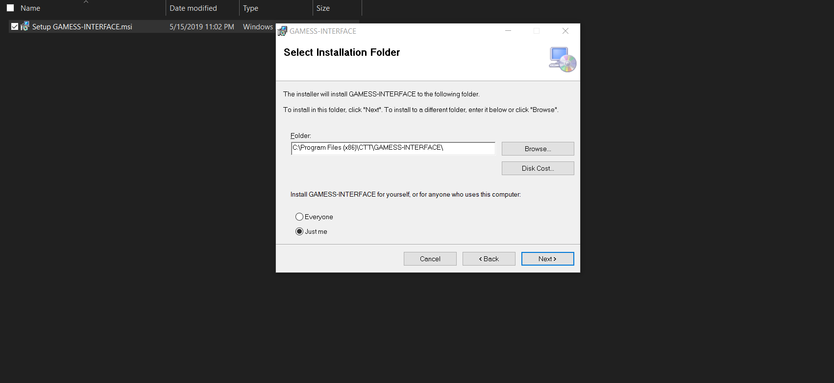

The default path is shown in the installer. If you wish to change the installation path click the browse button.

Click on next to this and the following screen of the installation process.

Give administrator privileges when asked.

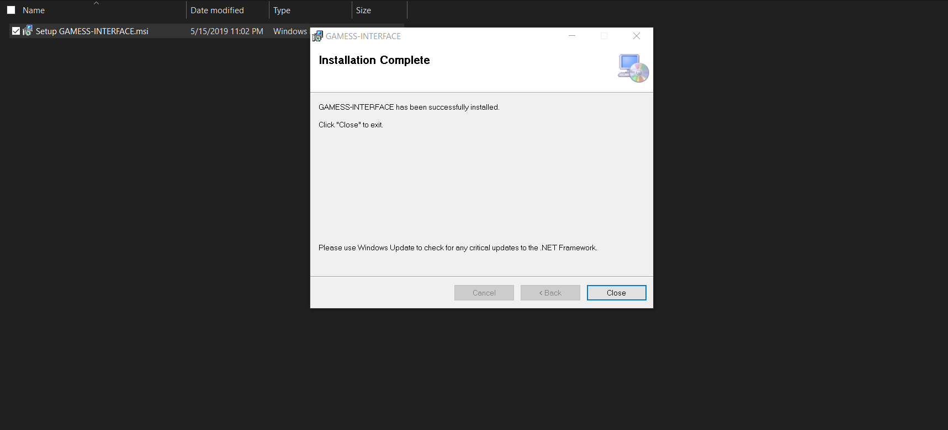

Click on Close.

The installation does not require a system restart.

First time run and set up

When the installation process is complete you can start using the program.

NOTE: GAMESS-INTERFACE will automatically detect if GAMESS is installed on your system. If a valid GAMESS install cannot be found you’ll see the following message.

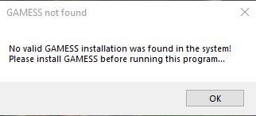

The software has the option to send via email the WFN file (wave function file output) generated. In order to enable this feature, you have to enter a valid email address and its password for the email sending process. You have to specify the receiver email to which the output file will be sent too

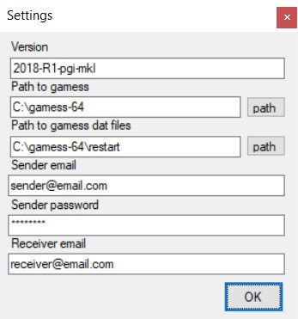

NOTE:

* Current version (1.0.0.0) only supports Gmail sender accounts.
* due to attachments limitations the maximum file size is set to 25MB. Any file larger than that won’t be sent with the email.

If you don’t want to enable the email feature you can leave those fields empty.

Click on OK.

GAMESS Job Run

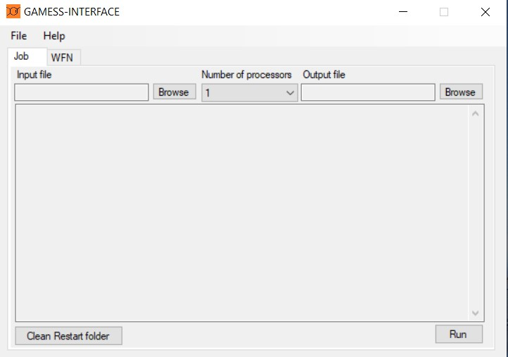

This software provides the user an intuitive user interface compared to the classic command -line style interface given by the GAMESS software.

To run a GAMESS job you have to set up some parameters:

* Input file location
* Number of processors (notes about this value can be found in the following section)
* Output file location

The input file MUST be an INP (\*.inp) file. The default output file is a LOG (\*.log) and can be imported into software like “Avogadro” to simulate Orbitals and other chemical objects.

NOTES:

* Input file MUST NOT contain whitespaces, otherwise the program cannot send the file to the GAMESS elaboration scripts.
* the “Number of processors” combo box indicates the number of instances that GAMESS will create in order to spread the workload and, therefore, optimize the process. The current version of this interface does NOT provide multi nodes support.

To execute the calculations, click on Run.

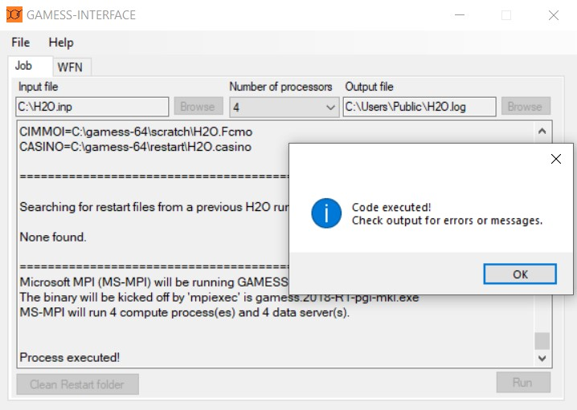

Once the execution has completed a message dialog will provide the user some information about the GAMESS job.

Old PUNCH

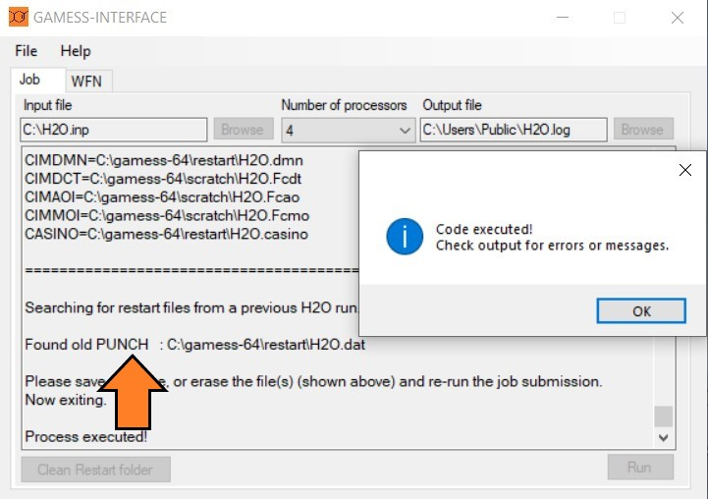

In some cases, the execution might return the message “Found old PUNCH”. That means that an older execution of the same data has been done in a previous run.

To solve this simply click on the “Clear Restart folder”. This will clear any old PUNCH that might avoid the execution of the calculations.

After that you can click on Run again and check the output.

WFN data extraction

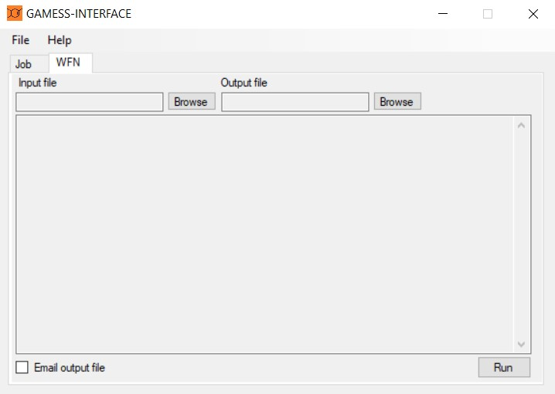

Despite its computational power and features GAMESS does NOT provide a separated WFN file (wave function file). This type of file is used to compute a graphical view of data like Advanced Molecular Orbitals, Electron Density and visualization of Lone Pairs in a molecule. However, those data are included in the DAT (data file) used by GAMESS to compute the INP file.

To extract wave function data, you have to specify:

* Input file location (this would be the restart folder containing the “\*.dat” files)
* Output file location

To execute the extraction, click on Run.

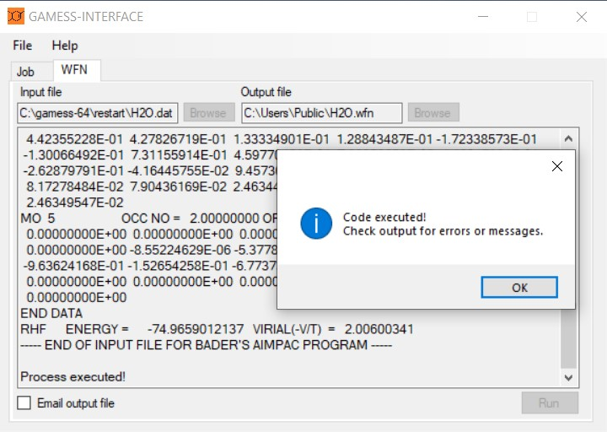

Once the extraction has completed a message dialog will provide the user some information about the WFN data found.

NOTE: if the DAT file does NOT have AIMPAC data the process will return an error message telling you that no valid data has been found.

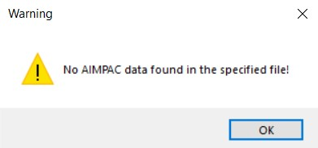

Send WFN file via email

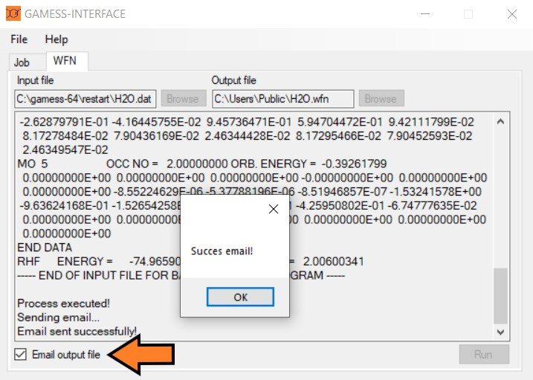

To enable the email feature, you have to set up the email settings in the “Settings” form and check the “Email output file” box at the left bottom of the WFN tab window.

After doing that you can simply click on Run and the email will be sent at the end of the process.

NOTE:

* in case of incorrect sender credentials, the program will return the following error message.

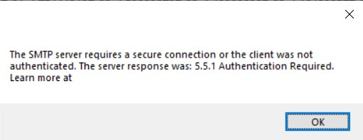

* wrong receiver email address won’t trigger any warning in the program and return a successful email sending.

Email example

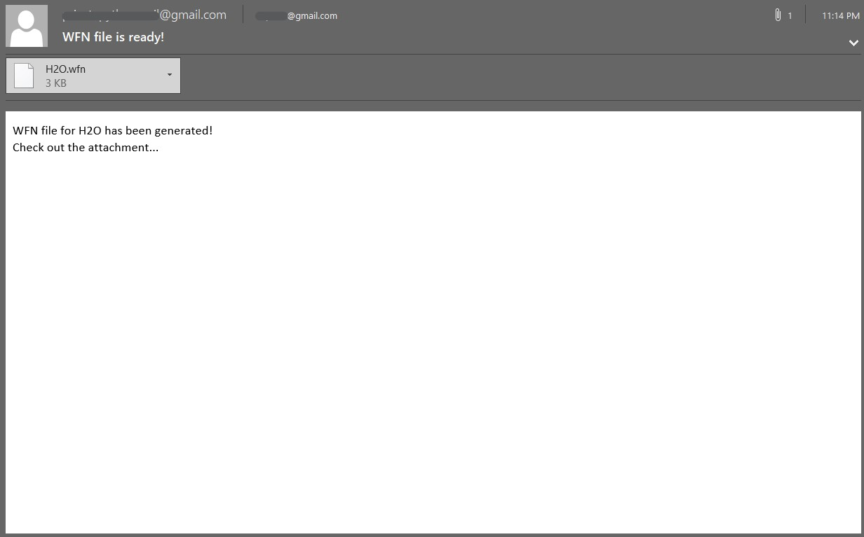

Here is an example of the email that the user will receive after the execution. As you can see the body include the name of the analyzed molecule and the attachment is the generated WFN file.